IntelleSence is one of the best things to happen in the history of coding. Ever. I can't remember the last time I had to type an entire line of code. And I don't need to tell you how helpful it is to see the entire list of function parameters as you type.
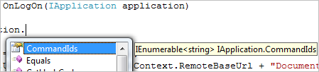
Well here is something to make intelleSense more useful when using the Vault API. There are some XML files that you can put in the same folder next to the Autodesk DLLs that you link to. When these XML files are in place Visual Studio will include comments into the intelleSense. These are the same comments use use in the SDK documentation.
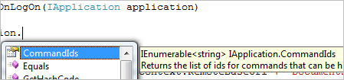
Downloads:
Autodesk.Connectivity.Explorer.Extensibility.XML
Autodesk.Connectivity.JobProcessor.Extensibility.xml
Unfortunately we only have XML files for the Vault Client and Job Processor APIs. Maybe I can get around to the Web Service API for the next release.

